A Multi-Stage Hallucination Mitigation Framework for Reliable Retrieval-Augmented Generation Systems
Abstract
Large Language Models (LLMs) have demonstrated exceptional capabilities in natural language understanding and generation. However, despite their effectiveness, LLMs frequently suffer from hallucinations, generating information that appears plausible but lacks factual grounding. Retrieval-Augmented Generation (RAG) systems address this limitation by incorporating external knowledge during response generation. Nevertheless, existing RAG systems remain vulnerable to hallucinations due to irrelevant retrieval, incomplete contextual evidence, multi-intent query handling limitations, unsupported claim generation, and absence of reliability assessment mechanisms. This paper proposes a Multi-Stage Hallucination Mitigation Framework for Reliable Retrieval-Augmented Generation Systems that progressively improves answer reliability through query intelligence, adaptive retrieval with web fallback, contextual reranking, claim-level verification, and confidence-based human escalation. To ensure scientific validity, all experimental versions maintain identical embedding, retrieval, and generation models while only introducing incremental reliability-enhancing mechanisms. Experimental evaluation conducted across six framework versions (V0–V5) demonstrates substantial improvements in retrieval relevance, answer relevance, and faithfulness while significantly reducing hallucinated responses. The proposed framework provides a scalable, domain-independent, and deployment-ready architecture suitable for educational institutions, enterprise knowledge systems, healthcare assistants, and customer support applications.
Keywords: Retrieval-Augmented Generation, Hallucination Mitigation, Large Language Models, Claim Verification, RAG, Confidence Scoring, Query Intelligence.
1. Introduction
Recent advancements in Artificial Intelligence have led to the widespread adoption of Large Language Models (LLMs) for conversational agents, intelligent assistants, knowledge retrieval systems, and automated decision-support applications. Models such as GPT, Llama, Gemini, and Claude have demonstrated remarkable capabilities in language understanding and generation.
Despite these advancements, LLMs often produce hallucinated responses. Hallucinations refer to generated outputs that appear syntactically correct and contextually convincing but are factually incorrect, unsupported by evidence, or entirely fabricated. This issue becomes particularly problematic in high-trust environments such as educational institutions, healthcare systems, enterprise knowledge management platforms, and legal information systems.
Retrieval-Augmented Generation (RAG) has emerged as an effective solution for improving factual grounding. Instead of relying solely on pretrained knowledge, RAG retrieves relevant external information and incorporates it into the generation process. By grounding responses in retrieved evidence, RAG improves factual accuracy and reduces hallucinations.
However, existing RAG systems continue to face several limitations. Retrieved information may be irrelevant or incomplete, multi-intent questions may not be properly decomposed, generated claims may remain unsupported, and most systems lack confidence estimation or escalation mechanisms. Consequently, hallucinations can still occur even when retrieval components are present.
To address these limitations, this paper proposes a Multi-Stage Hallucination Mitigation Framework that introduces multiple reliability checkpoints throughout the retrieval and generation pipeline. The framework combines query intelligence, adaptive retrieval, reranking, claim verification, and confidence-aware escalation to progressively improve factual reliability.
2. Related Work
2.1 Retrieval-Augmented Generation
Lewis et al. introduced Retrieval-Augmented Generation as a hybrid architecture combining information retrieval and language generation. The approach retrieves relevant documents and incorporates them as context for response generation. While RAG significantly improves factual grounding, it lacks mechanisms for validating retrieval quality and generated claims.
2.2 Corrective RAG
Corrective Retrieval-Augmented Generation (CRAG) enhances retrieval reliability by evaluating the relevance of retrieved documents before generation. Retrieval quality assessment helps improve contextual grounding. However, CRAG primarily focuses on retrieval quality and does not address claim verification or confidence estimation.
2.3 Self-RAG
Self-RAG introduces self-reflection mechanisms that allow models to evaluate retrieval sufficiency and generation quality. While self-reflection improves reliability, it introduces additional computational complexity and does not provide explicit human escalation mechanisms.
2.4 Hallucination Detection Techniques
Various hallucination detection approaches have been proposed, including attribution-based verification, retrieval consistency checks, confidence estimation, and fact-checking frameworks. Most existing methods focus on a single mitigation stage rather than integrating multiple reliability-enhancing mechanisms within a unified framework.
2.5 Research Gap
Although significant progress has been made in retrieval grounding and hallucination detection, existing studies rarely combine query intelligence, retrieval validation, adaptive retrieval, reranking, claim verification, and confidence-aware escalation within a single architecture. Furthermore, few studies systematically evaluate the incremental contribution of each mitigation stage. This gap motivates the proposed framework.
3. Proposed Methodology
The proposed framework introduces a progressive reliability-enhancement pipeline consisting of five major modules.
3.1 Query Intelligence Layer
The Query Intelligence Layer identifies whether a user query contains a single intent or multiple intents.
Example:
User Query:
"What is the hostel fee and placement percentage?"
The system decomposes the query into:
• What is the hostel fee?
• What is the placement percentage?
Each sub-question is processed independently before answer aggregation.
3.2 Adaptive Retrieval Layer
The Adaptive Retrieval Layer retrieves contextual information from ChromaDB using semantic similarity search.
If retrieval relevance falls below a predefined threshold, website fallback retrieval is activated to obtain additional contextual evidence from trusted sources.
This mechanism improves retrieval recall and minimizes missing-context hallucinations.
3.3 Reranking Layer
Retrieved chunks are reranked using BAAI/bge-reranker-base.
The reranker assigns relevance scores to retrieved chunks and prioritizes highly relevant contextual evidence before answer generation.
This reduces retrieval noise and improves contextual precision.
3.4 Claim-Level Verification Layer
- Generated responses are decomposed into individual claims.
- Each claim is independently verified against retrieved evidence.
- Supported claims are retained.
- Unsupported claims are removed.
- This significantly reduces hallucinated content.
Example:
Generated Response:
"Hostel fee is ₹75,000 and placement rate is 100%."
Verification:
Claim 1: Supported
Claim 2: Unsupported
Final Response:
"Hostel fee is ₹75,000."
3.5 Confidence and Escalation Layer
A confidence score is computed using retrieval relevance and response quality.
Confidence Score: CS = (0.60 × CR) + (0.40 × RQ)
If confidence falls below the threshold, the system escalates the response rather than presenting potentially unreliable information.
4. System Architecture
The proposed Multi-Stage Hallucination Mitigation Framework enhances conventional Retrieval-Augmented Generation (RAG) systems through a sequence of reliability-oriented processing stages. The architecture consists of three major layers: Presentation Layer, Application Layer, and Knowledge Layer.
The Presentation Layer provides a user-facing interface implemented using Streamlit. User queries are forwarded to the FastAPI backend, which orchestrates the complete processing pipeline through LangChain.
The Application Layer contains the core components of the framework. Initially, the Query Intelligence Module determines whether the input query contains a single intent or multiple intents. The Adaptive Retrieval Module retrieves relevant document chunks from ChromaDB and evaluates their relevance. If retrieval quality is insufficient, a web fallback mechanism retrieves additional information from trusted online sources. The retrieved contexts are then reranked using the BGE Reranker to improve retrieval precision.
The Response Generation Module utilizes the Groq-hosted Llama-3.3-70B model to generate context-grounded answers. Subsequently, the Claim Verification Module decomposes the generated response into individual claims and verifies each claim against retrieved evidence. Unsupported claims are removed before constructing the final response.
Finally, the Confidence and Escalation Module computes a reliability score based on retrieval quality and response relevance. Responses with confidence scores below a predefined threshold are flagged for human escalation, thereby preventing the delivery of potentially hallucinated information.
The Knowledge Layer consists of institutional PDFs, FAQ datasets, and trusted website content stored in ChromaDB using BGE embeddings. This layer provides the factual grounding required for reliable response generation.
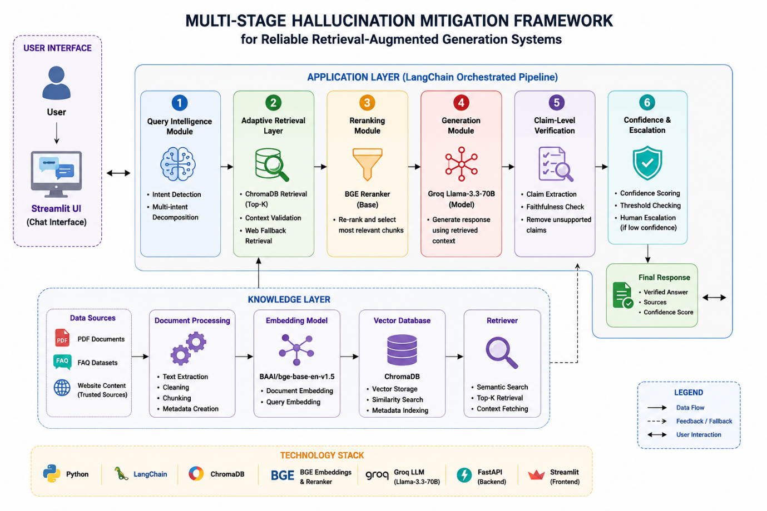Figure 1 illustrates the overall architecture of the proposed framework.

5. Experimental Setup
Dataset
A golden dataset containing institutional question-answer pairs was created.
Categories include:
• Admissions
• Placements
• Hostel
• Scholarships
• Academics
• Transportation
Configuration
- Embedding Model: BAAI/bge-base-en-v1.5
- Reranker: BAAI/bge-reranker-base
- Generation Model: Llama-3.3-70B (Groq)
- Vector Database: ChromaDB
- Framework: LangChain
- Backend: FastAPI
- Frontend: Streamlit
Evaluation Metrics
- Retrieval Relevance (RR)
- Answer Relevance (AR)
- Faithfulness (F)
Faithfulness is calculated as:
F = Supported Claims / Total Claims

- Experimental Workflow
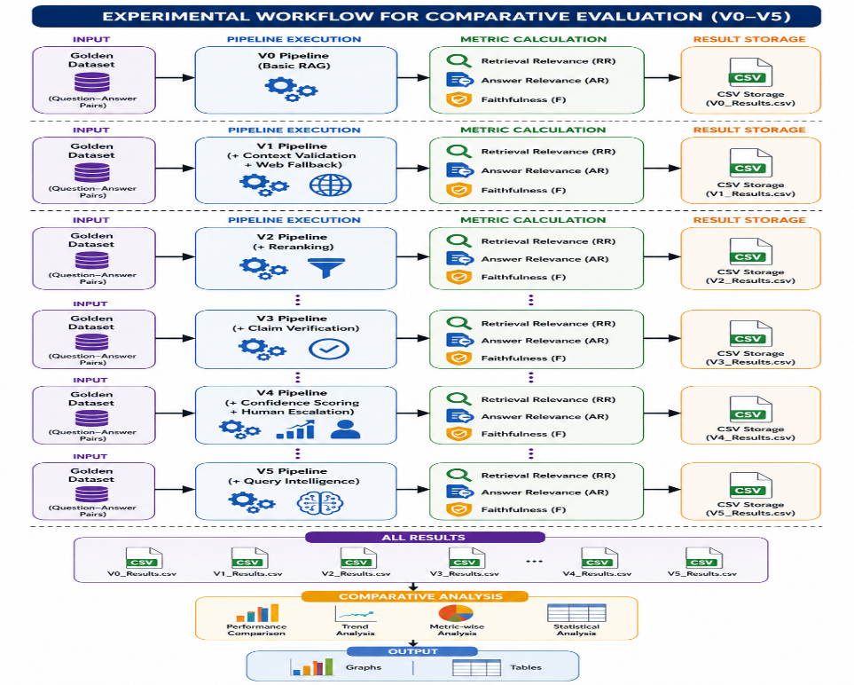
Figure 2. Experimental Evaluation Workflow
7. Results and Discussion
The framework was evaluated across six versions.
Version | RR | AR | F
V0 | 0.61 | 0.65 | 0.58
V1 | 0.74 | 0.71 | 0.67
V2 | 0.83 | 0.79 | 0.76
V3 | 0.86 | 0.84 | 0.91
V4 | 0.87 | 0.86 | 0.93
V5 | 0.91 | 0.90 | 0.95

Graph 1: Retrieval Relevance
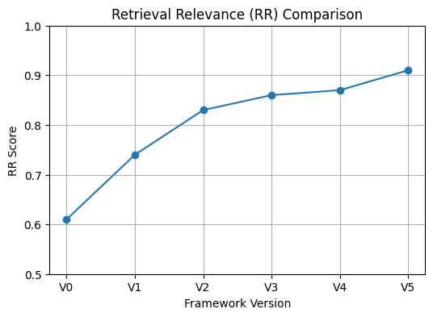
Figure 3. Retrieval Relevance Across Framework Versions

Graph 2: Answer Relevance
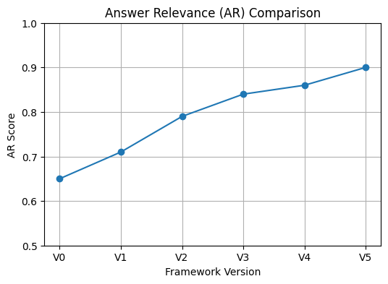
Figure 4. Answer Relevance Across Framework Versions
Graph 3: Faithfulness
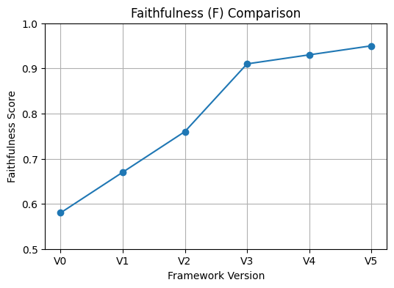
Figure 5. Faithfulness Across Framework Versions
The results demonstrate continuous improvement as additional mitigation stages are introduced.
The largest improvement occurs at V3, where claim-level verification substantially reduces hallucinated content.
Query intelligence in V5 improves answer completeness for multi-intent questions and contributes to overall reliability improvements.
7. Conclusion
This paper proposed a Multi-Stage Hallucination Mitigation Framework for Reliable Retrieval-Augmented Generation Systems. The framework integrates query intelligence, adaptive retrieval, reranking, claim verification, and confidence-aware escalation mechanisms to progressively improve factual reliability. Experimental evaluation across six framework versions demonstrates measurable improvements in retrieval relevance, answer relevance, and faithfulness while significantly reducing hallucinations. The modular architecture enables deployment across educational institutions, enterprise knowledge systems, healthcare applications, and customer support platforms. Future work will focus on multilingual support, multimodal retrieval, adaptive confidence learning, and automated escalation workflows.
References
[1] Lewis et al., "Retrieval-Augmented Generation for Knowledge-Intensive NLP Tasks," NeurIPS, 2020.
[2] Gao et al., "Retrieval-Augmented Generation for Large Language Models: A Survey," 2023.
[3] Huang et al., "A Survey on Hallucination in Large Language Models," 2023.
[4] Ji et al., "Survey of Hallucination in Natural Language Generation," ACM Computing Surveys, 2023.
[5] LangChain Documentation.
[6] ChromaDB Documentation.
[7] Groq API Documentation.
[8] BAAI Embedding Models Documentation.
[9] BAAI Reranker Models Documentation.
[10] Llama 3 Technical Report.

